

Part IV: The product
ACCESS

Access: Accessible City & Community Engagement Support System

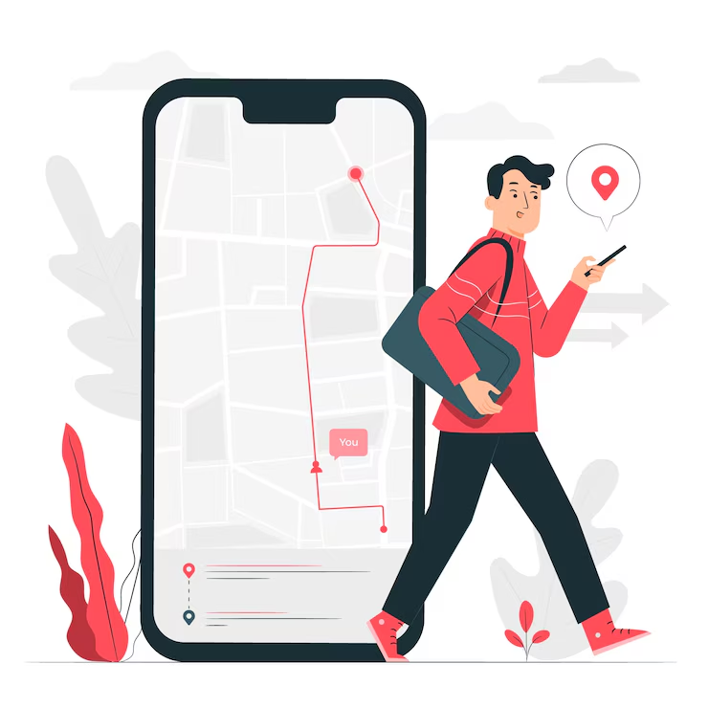

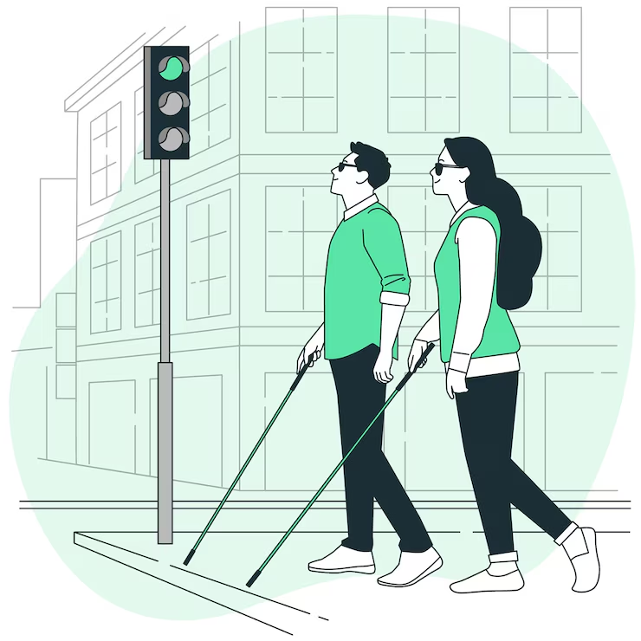
Access is a mobile application designed to assist individuals with disabilities in navigating urban environments with greater ease and independence. It provides detailed accessibility information for various locations and routes, enabling users to identify the degree of accessibility and determine the most accessible way to reach their destination. We will address the real-life challenges encountered by users and present visual mockups in Figma to showcase the application's design and functionality.

Real-Life Challenges
- Inadequate accessibility data in current navigation apps
- Difficulty finding accessible routes that avoid obstacles
- Lack of real-time updates on accessibility issues
- Gathering user feedback on accessibility experiences

Assumptions:
- Users are willing to use a smartphone to plan accessible routes.
- Public authorities and businesses will collaborate to provide access to cross-checked accessible data.
- The necessary technology (map APIs, real-time updates, voice commands, adaptive interfaces) is available and can be effectively integrated.
- Revenue streams (ads, partnerships, etc.) will be sufficient to cover operational and maintenance costs.

Constraints:
- Complexity of integrating data from multiple sources (crowdsourced + official data).
- Challenges in maintaining data accuracy and ensuring information stays up to date.
- Need for strict compliance with data privacy regulations (like GDPR).
- High development costs, especially for designing custom interfaces for accessibility (e.g., voice commands, adjustable visuals).
- UX design challenges to meet the needs of users with various types of disabilities.


Figma Mockups
Access application mockups can be viewed at the following links. Explore our fully functional prototype, in the second link for firsthand insight into the app's key features, user flow, design, and functionality.
- https://www.figma.com/design/G95SAz9UyBvHODPsz0b5VE/access?node-id=0-1&t=Wt9Vcs9tj6tx61Mz-1
- https://www.figma.com/proto/G95SAz9UyBvHODPsz0b5VE/access?node-id=1-3413&t=honinMQHZ7dLFMFp-1&scaling=scale-down&content-scaling=fixed&page-id=0%3A1&starting-point-node-id=12%3A1109

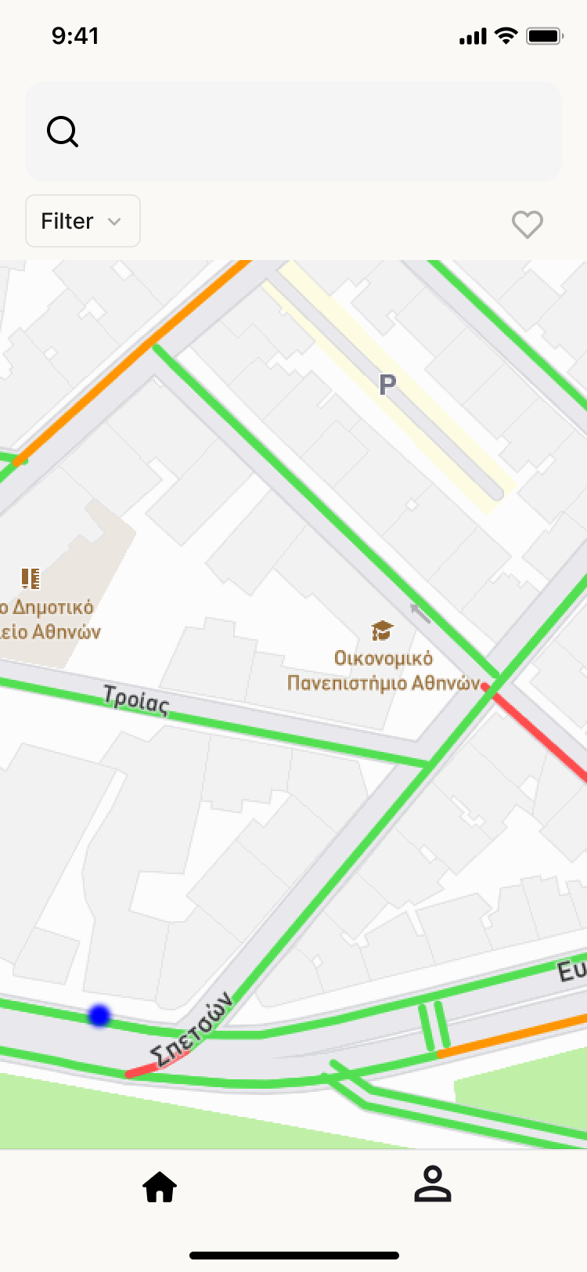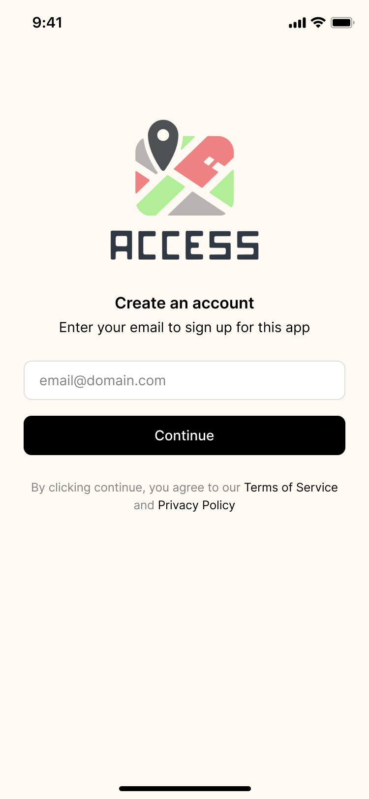

The mockups demonstrate the login interface where users can securely enter their credentials. Upon successful login, users gain access to contribute to the app by submitting reports and mapping the area.

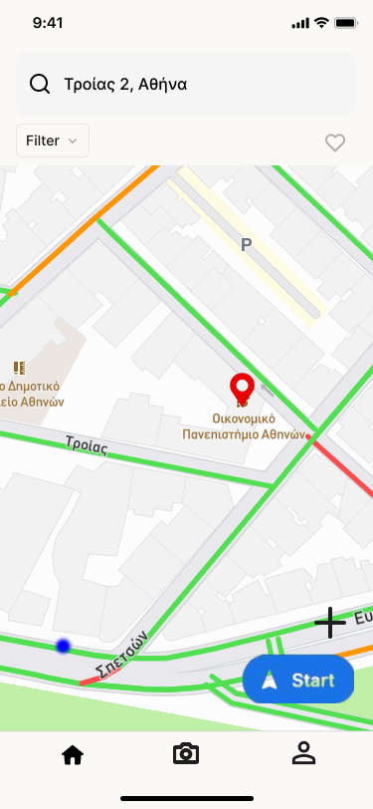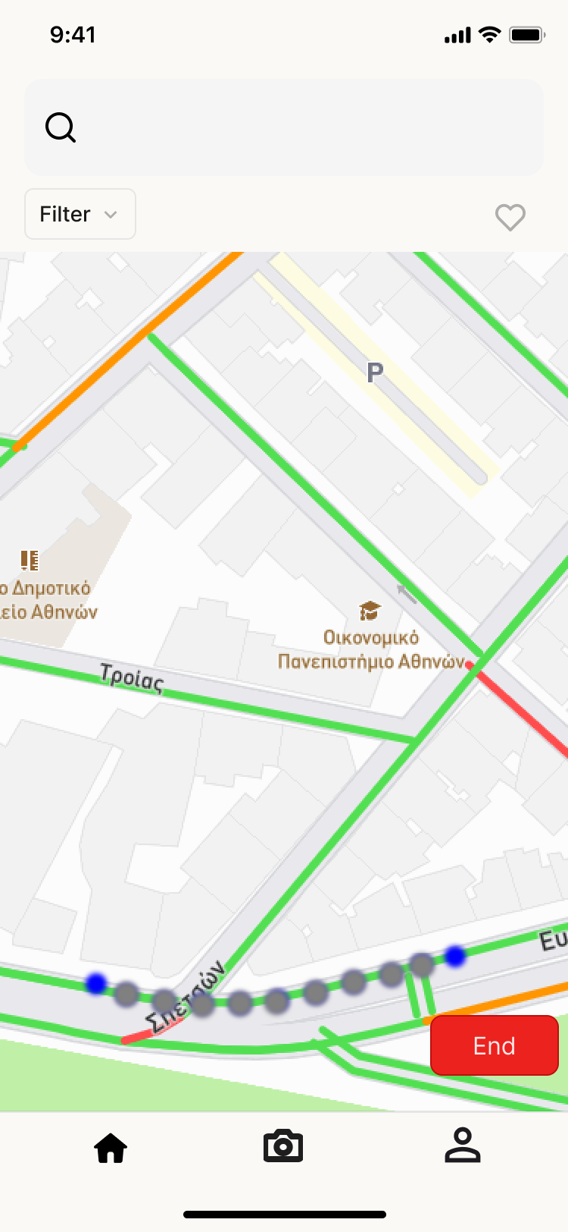

The prototype displays a map interface with a "Start" button, indicating a feature where users can contribute to the app by mapping accessible routes. Users can then trace their accessible route, adding details such as obstacles, surfaces, and accessibility features along the way.

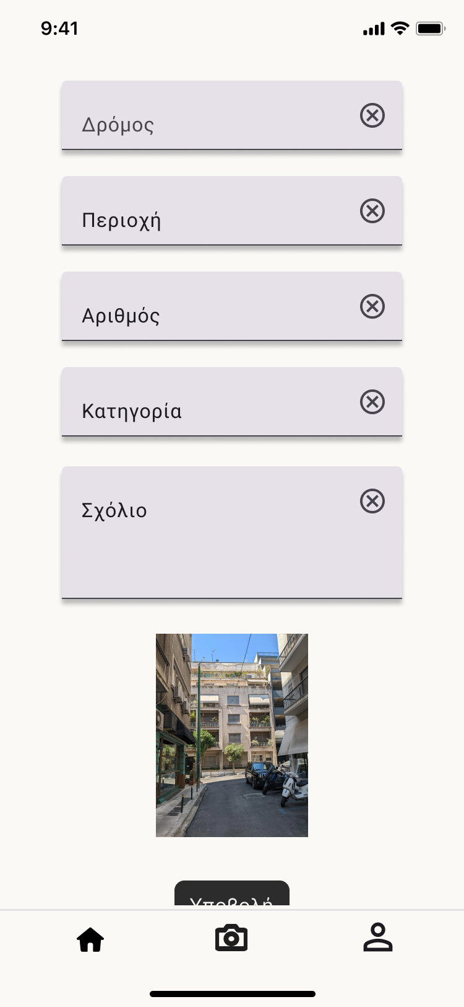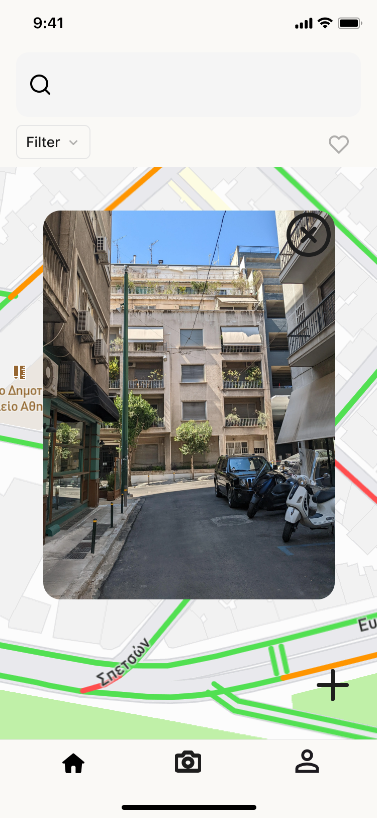

For the first mockup, we see someone filling out a form to report a new obstacle on their route, saying what it is and where it is. Then, in the second mockup, their full report shows up, picture included, ready for others to see.

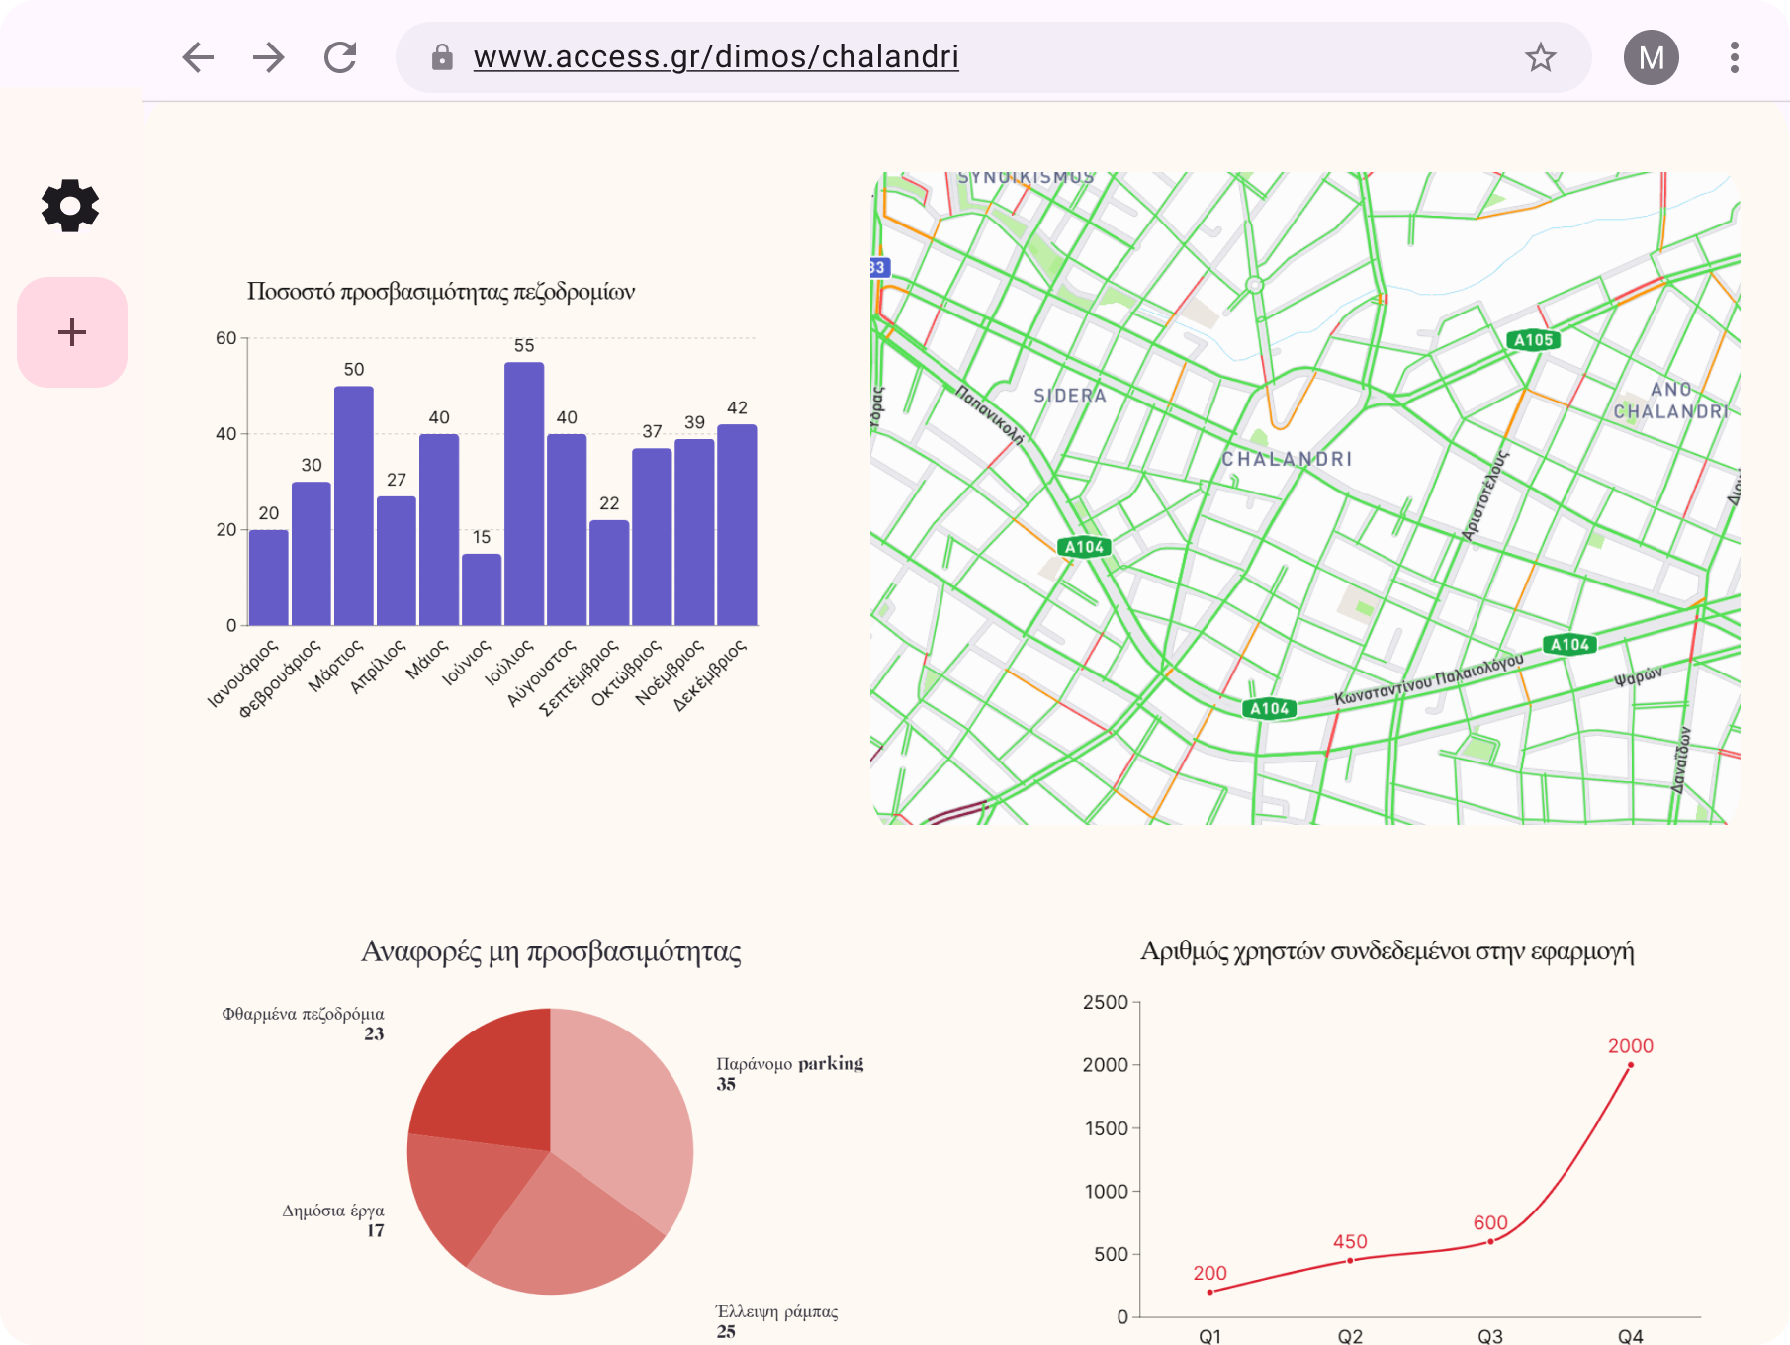

A municipality dashboard provides an overview map with accessibility statistics, enabling officials to visualize data. The dashboard also includes a submission form for reporting new construction or updates to existing accessibility features within the city.

